RAILWAY RESERVATION SYSTEM

* PL/SQL CODE SNIPPETS, TABLES AND OUTPUTS:

Login and Registration

reg_user table

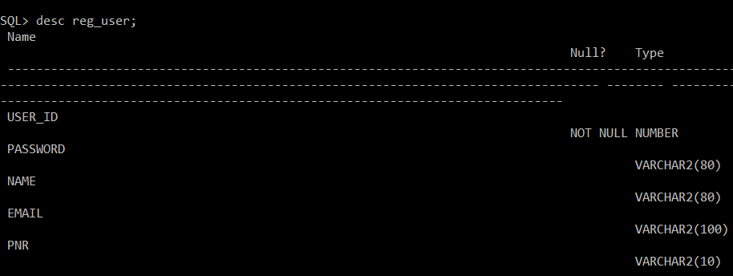

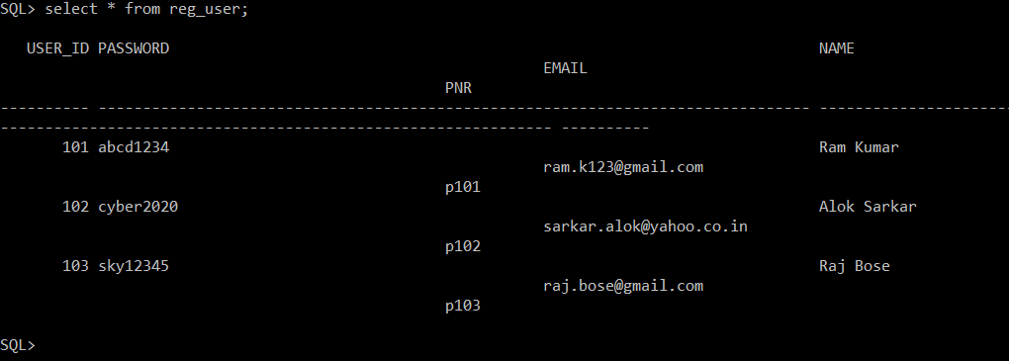

Registration PL/SQL

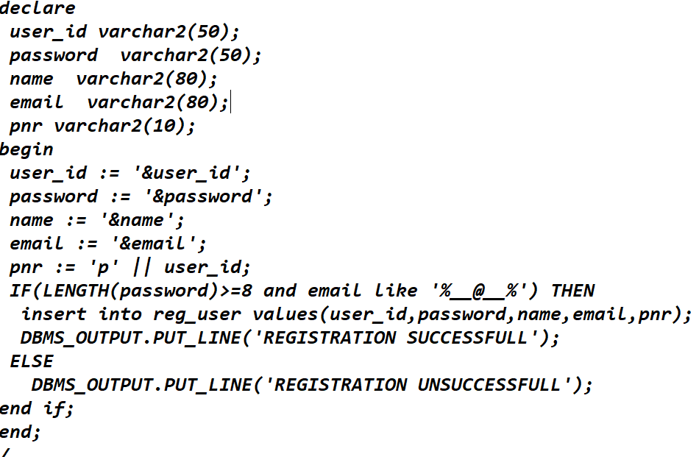

Registration and Login Checking output(successful output)

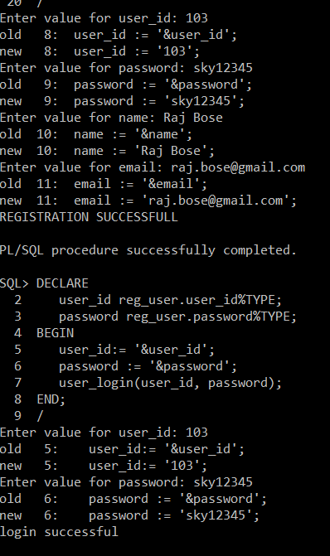

Registration output(unsuccessful output)

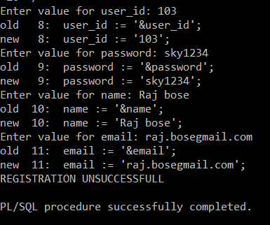

Login checking output(Successful)

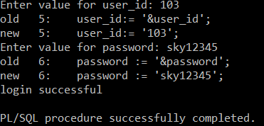

Login checking output(Error Login Output)

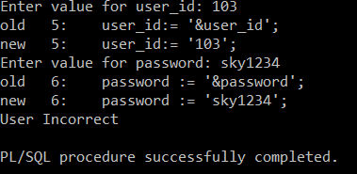

Login Checking PL/SQL(Already saved in Oracle DB)

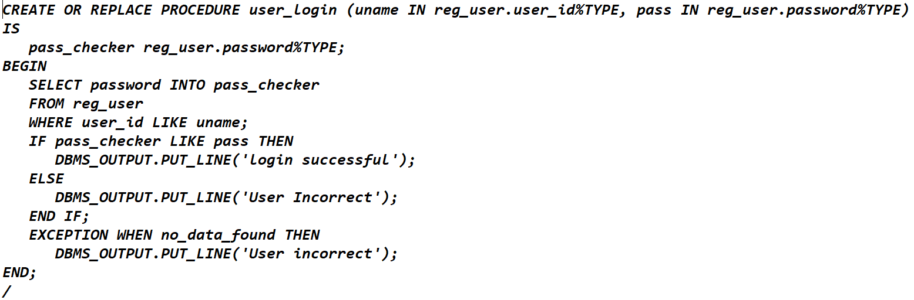

Calling the above procedure to login checking credentials

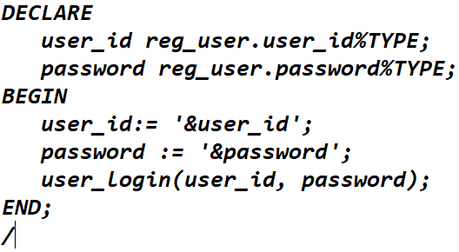

Train Viewing and Train Booking:

Train Table:

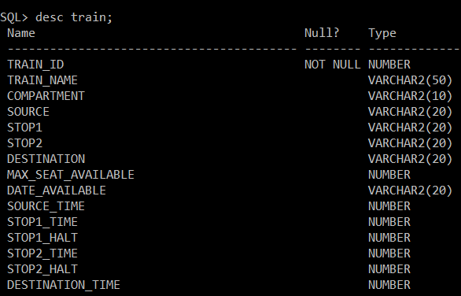

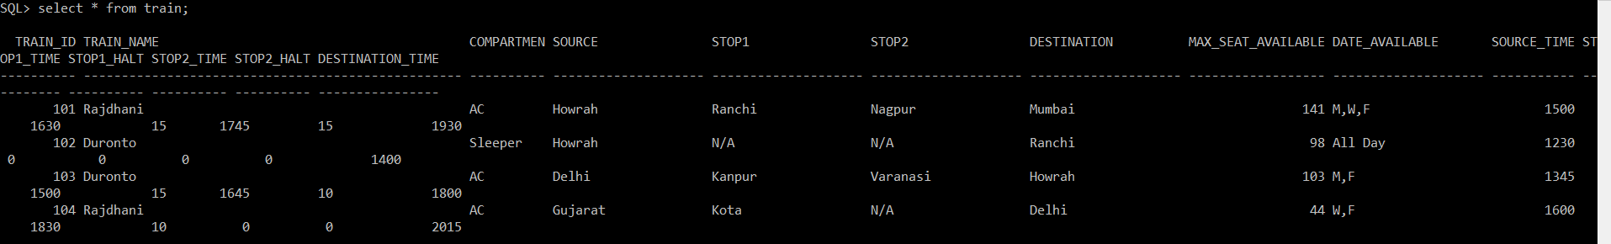

Train Viewing:

There are two trains from Howrah to ranchi, both Rajdhani and Duronto travels via same route.

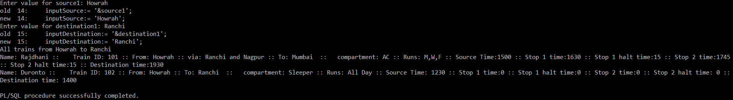

If user want to check specifically a train schedule.

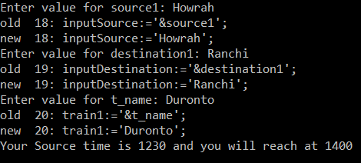

Train Viewing PL/SQL

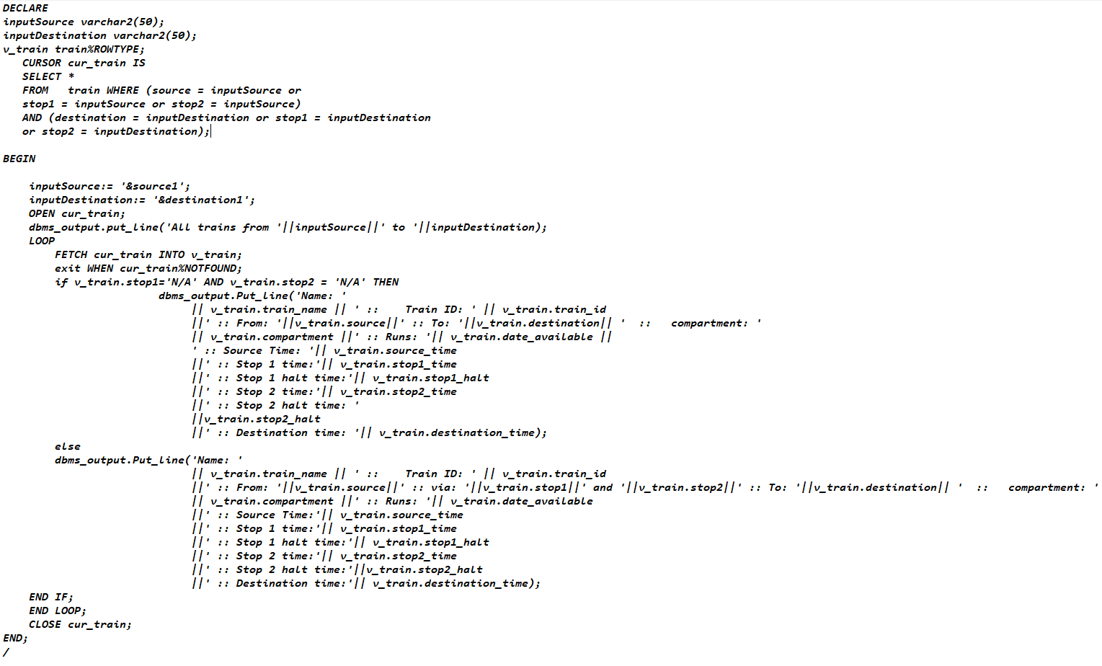

Train Schedule viewing PLSQL

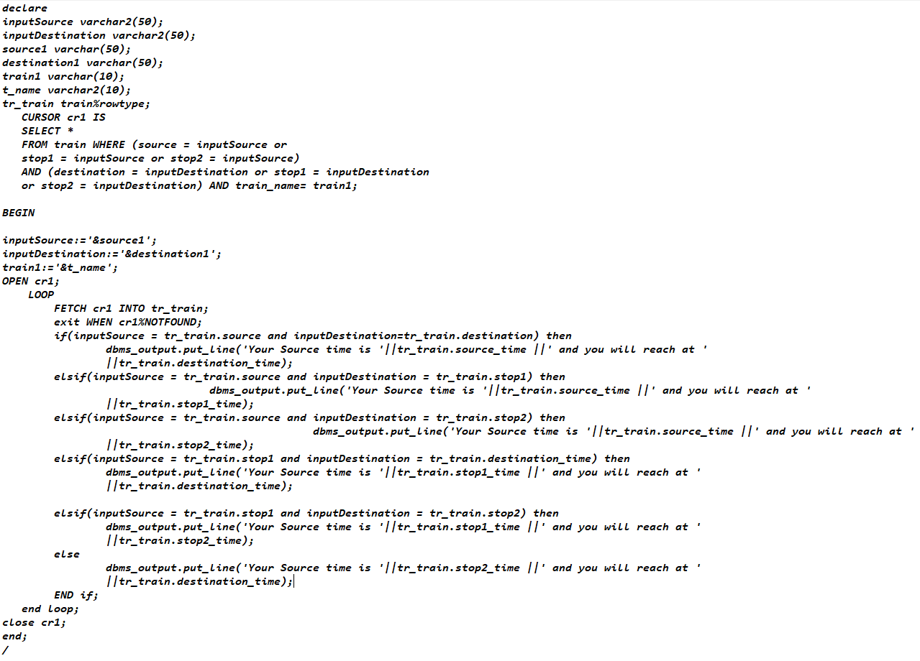

Train Booking Output(With automated berth generated)

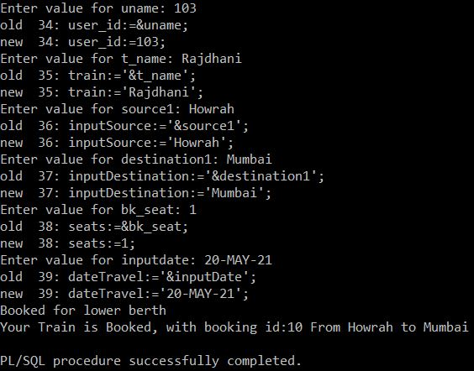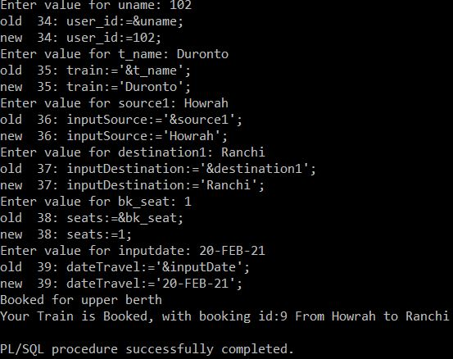

Train Booking PL/SQL

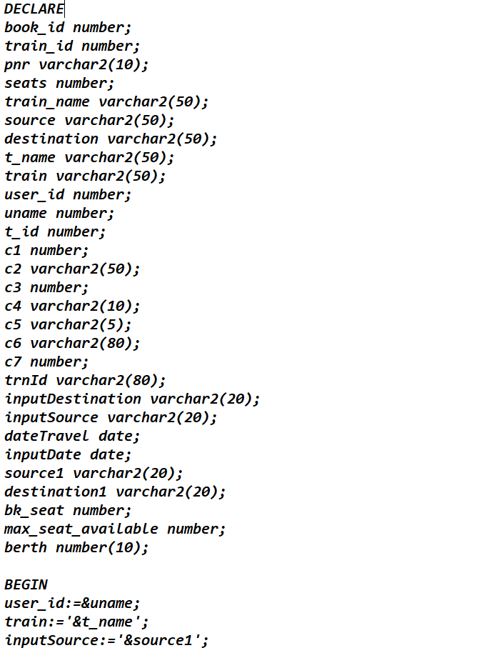

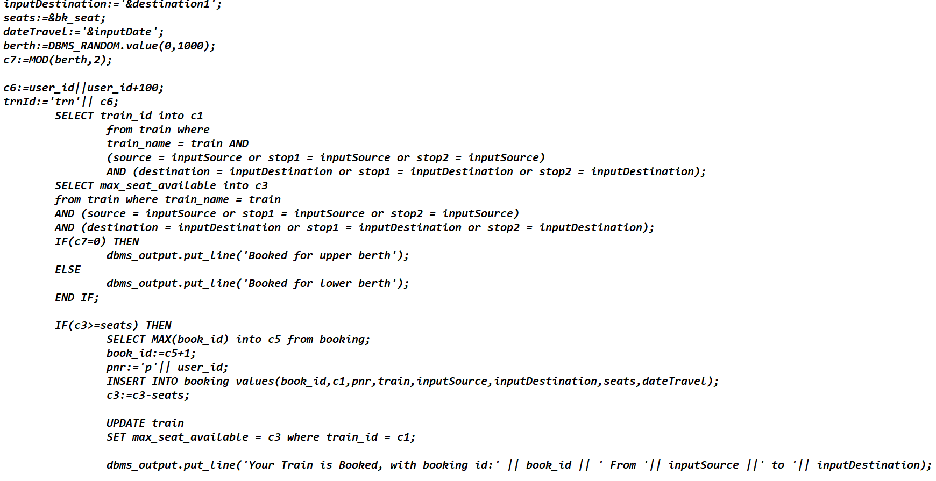

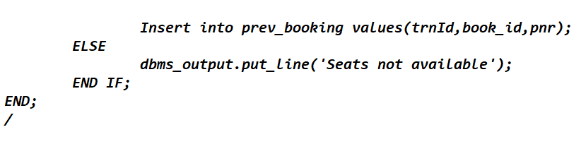

BOOKING TABLE

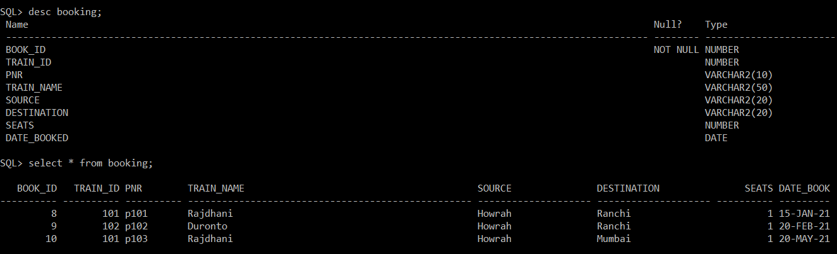

Prev_Booking table:

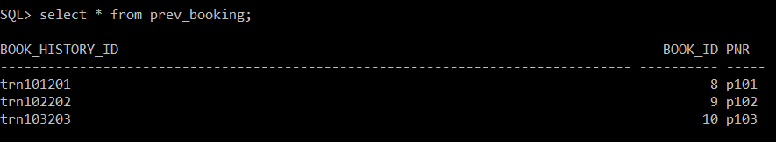

* ERD

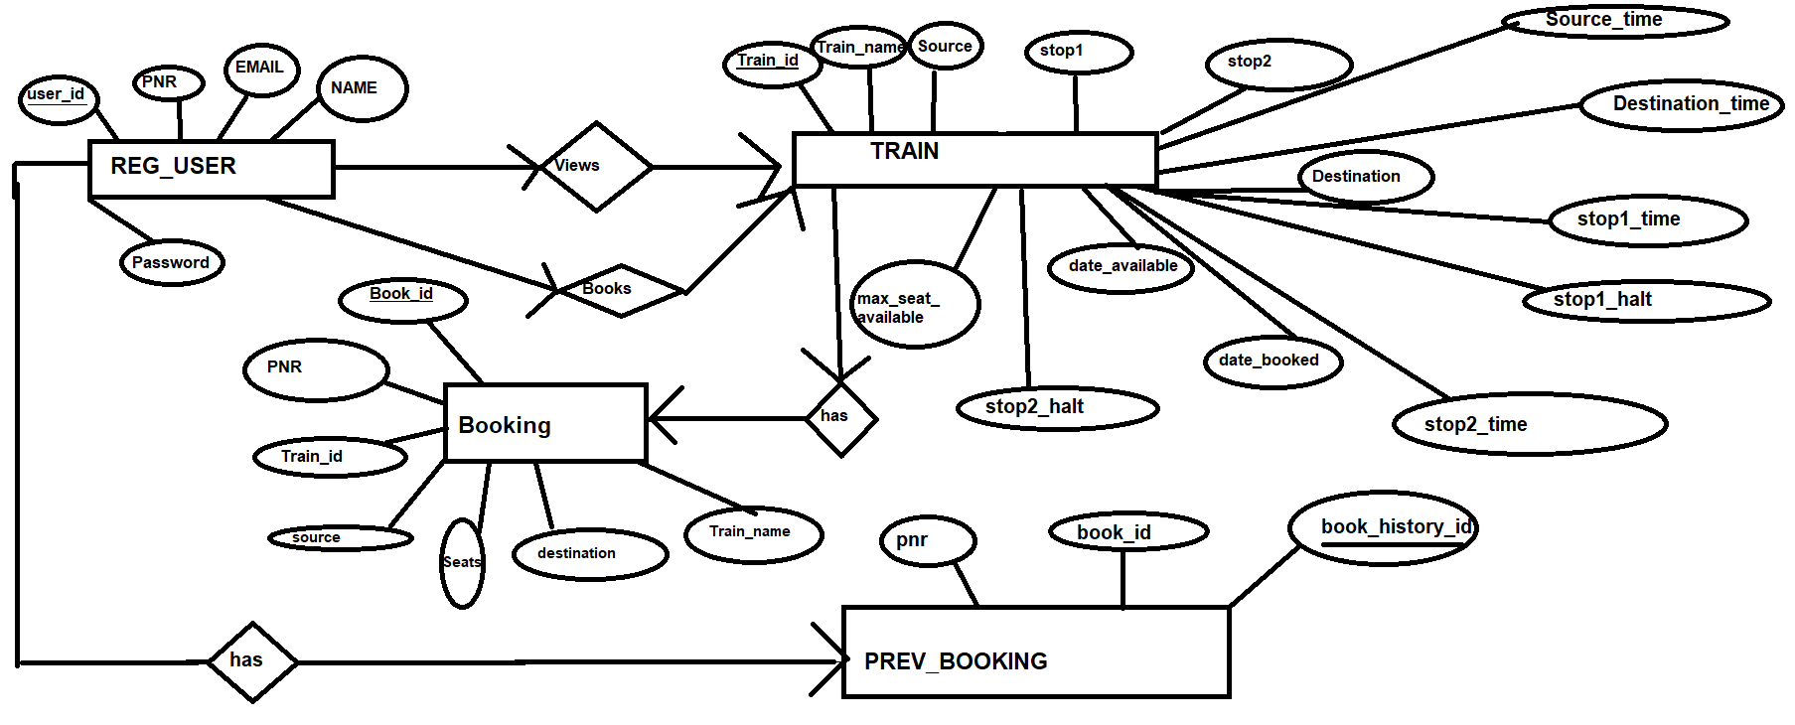

Cardinality and Process Flow Explanation from one attribute to another:

* REG_USER consists of **user_id** as primary key and also it consists of user’s detail like name, email, password and pnr is getting auto generated after registering.
* Then after registration is successful , the user needs to login with correct user_id and password to proceed further.
* Assuming successful login , a user can now view the available trains details by inputting source and destination.
* Now after viewing, according to user’s flexiblity he/she can book a train by simply inputting source, destination , train_name number of seats required and date of booking;
* After successful booking , the data of that booking with book_id being auto generated is inserted into booking table and corresponding train table’s max_seat_available is getting updated at the same point of time and simultaneously in prev_booking table where **book_history_id**(Primary Key in prev_booking table) is getting auto generated and book_id (Foreign key from booking table) getting auto inserted from booking table and pnr(foreign key from reg_user table) is getting auto inserted into prev_booking to maintain users booking history.
* Train table consists of **Train_id** as primary key and it contains the some attributes like train_name, source, destination, stop1 (as in stoppage 1) , stop2 (as in stoppage 2), destination and max_seat_available, source_time(Train starting time from main source), stop1_time(Train reaching time into stoppage 1), stop1_halt(Halt time into stoppage 1 after reaching stoppage1), stop2_time, stop2_halt, destination_time.
* The cardinality between REG_USER and train is that one user can view many trains , i.e One-Many relation when viewing and one user can book one train at a time so one-one relation when booking.
* Booking table consists of **book_id** as primary key and many attributes like pnr(foreign key from REG_USER table), train_id(foreign key from Train table),train_name(foreign key from Train table) , source and destination being referred from train table as well and seats(i.e, number of booked seats by that user) and date_booked( Booking date).
* The cardinality between Train and Booking is that one train has many booking, i.e one-many relation.
* The cardinality between REG_USER and PREV_BOOKING is one-many ,i.e a user can have history of booking.